**Summary of Data Analysis Project-1**

* First we have performed general analysis on dataset by reading the dataset. The dataset contains details of the used cars in germany which are on sale on ebay in 371528 rows and 20 columns, the columns are present in object and integer datatype, some columns have null values and duplicate values which have been removed or altered from the dataset.

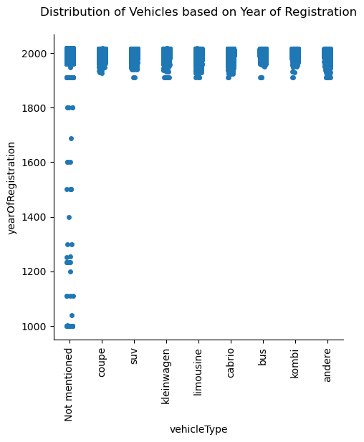

* The above plot shows the distribution of vehicles based on year of registration and vehicle type. We can see a huge number of vehicles are registered between the years 1900 and 2023.

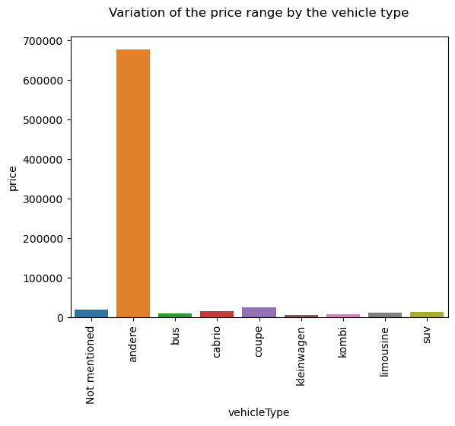

* The above plot shows the variation of price range by the vehicle type and as we can see andere, kleinwagen vehicles have the highest and least prices respectively.

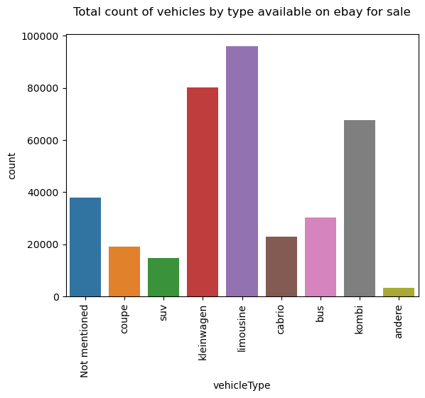

* The above plot shows the total count of vehicles by type available on ebay for sale. Kleinwagen and limousine stand at the top with the highest availability and suv, andere with the least availability.

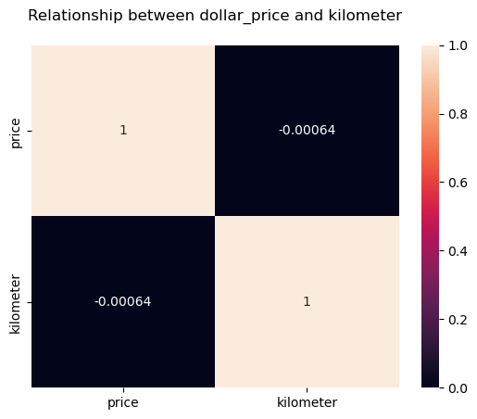

* The above plot is a heatmap showing the relationship between price and kilometers of the vehicles. From the map we can say that they have same values and they follow joint probability i.e. they both occur at the same time so they have same values.

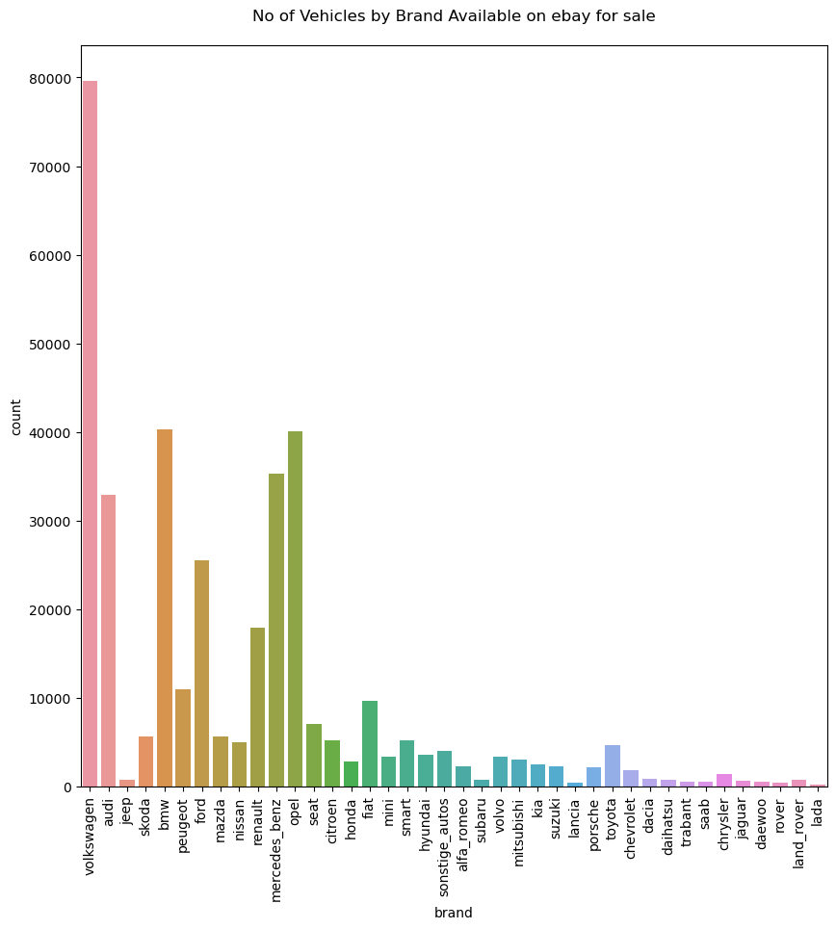

* The above plot shows the count of vehicles available by brand. Volkswagen and lada has the highest and lowest availability.

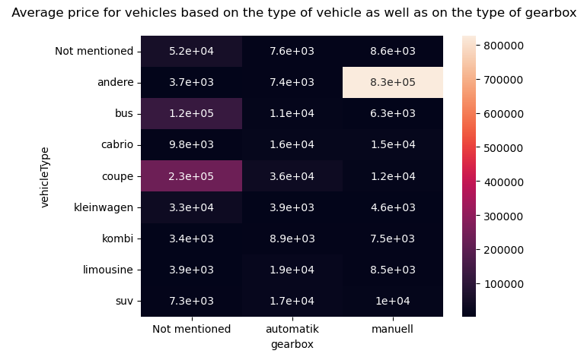

* The above plot shows the average price for vehicles based on the type of vehicle as well as on the type of gearbox. X-axis holds three gearbox types and y-axis holds different vehicle types and the values present in exponential form represent the averages or mean of prices corresponding to gearbox type and vehicle type.

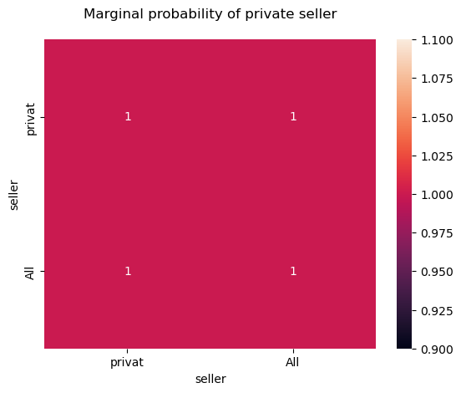

* The above plot shows the marginal probability of private seller which is equal to 1.

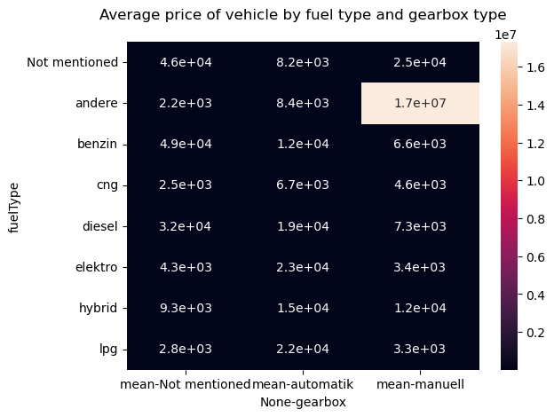

* The above plot is a heatmap showing the average price of vehicle by fuel type and gearbox type. Y-axis contains different fuel types and x-axis contains gearbox types and the mean or average prices of gearbox types.

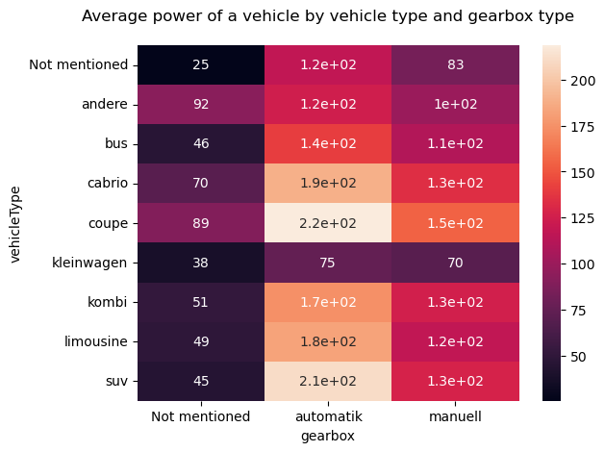

* The above plot is a heatmap of average power of a vehicle by vehicle type and gearbox type. Y-axis holds different vehicle types whereas x-axis has different gearbox types. The colour shades shows the density of points i.e. darker colours indicate highest average and lighter colours indicate lower average prices.

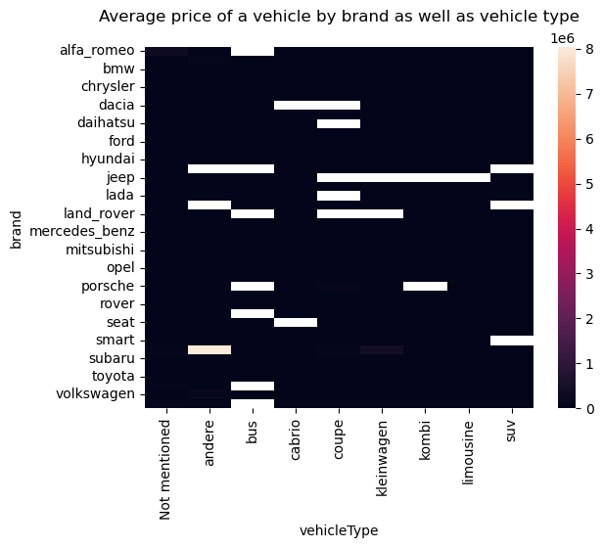

* The above plot is a heatmap showing average price of a vehicle by brand as well as vehicle type.